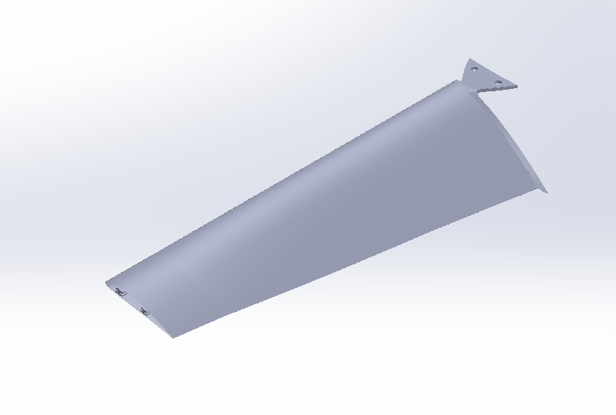

Fig -1 Fan Blade Isometric view (from the front)

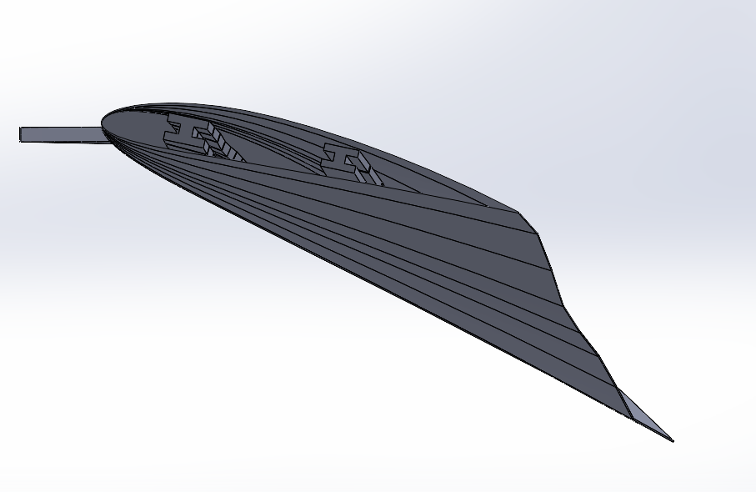

Fig -2 Fan Blade Front View

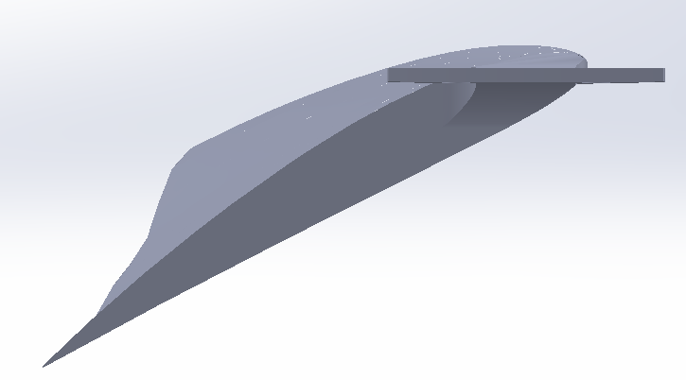

Fig -3 Fan Blade Back View

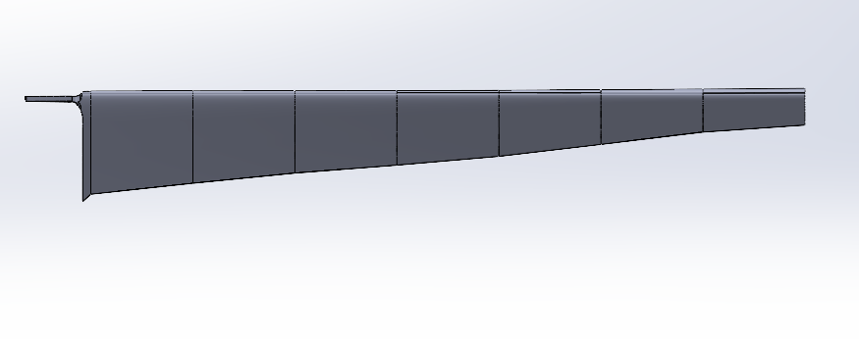

Fig -4 Fan Blade Left View

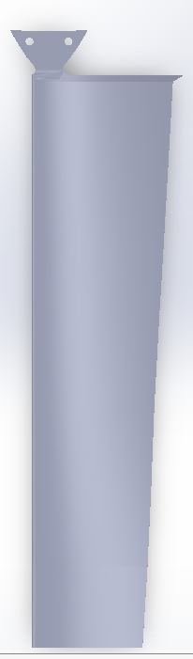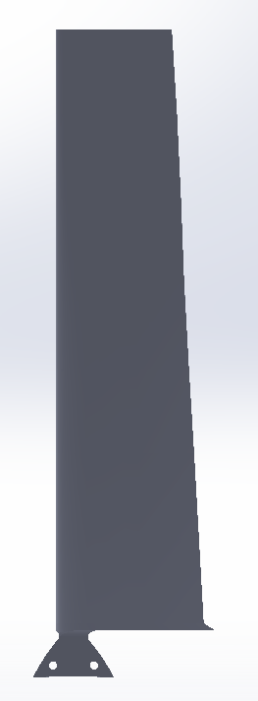Fig – 6 Fan Blade Bottom View

Fig – 7 Fan Blade Top View

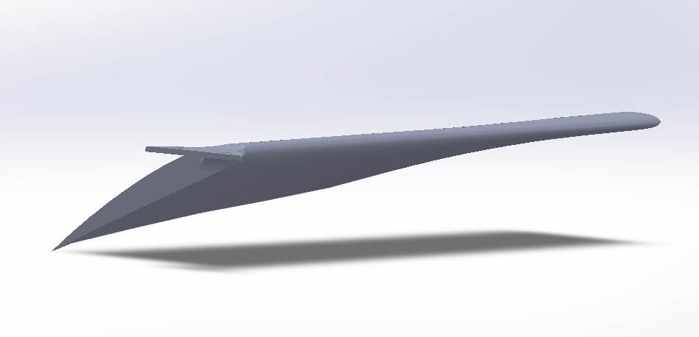

Fig – 8 Fan Blade Isometric View (from the Back)